

PRESS RELEASE
For immediate release
Hybrid Software Announces ‘Hybrid Fusion’ Customer Conference to Shape the Future of Labels and Packaging
Gent, Belgium, October 1st, 2024: Hybrid Software, leading developer of productivity tools for labels and packaging, is excited to announce its inaugural worldwide customer conference: Hybrid Fusion. This event will bring together package printing executives and prepress specialists from Hybrid’s 1,500 worldwide customers, along with industry experts, key OEM partners, and brand representatives. Hybrid Fusion will take place from April 22 – 25, 2025, in the vibrant city of Amsterdam.
Attendees will gain valuable insights from industry experts about the latest trends in labels and packaging across all printing processes: flexo, offset, gravure, digital, and hybrid printing. The Fusion event will showcase Hybrid Software’s innovative advancements in PDF editing, enterprise and cloud workflows, color and artwork management, proofing and 3D-prototyping, as well as the latest software and hardware offerings from a wide range of industry partners who will co-sponsor the event.
The conference will be highly collaborative so packaging printers can share best practices and request focused development by Hybrid Software and partners in the areas where innovation is needed. Ample opportunity for networking with product experts and fellow entrepreneurs will be provided throughout each day’s agenda as well as in the social events planned each evening.
“Our core philosophy, ‘We Share Your Heartbeat’, reflects our commitment to not only listen to our customers, but also to fully understand their needs and aspirations,” says CEO Mike Rottenborn. "At Hybrid Fusion, we’re not just presenting cutting-edge technology; we’re creating an open dialogue. This event is a chance for Hybrid Software and our industry partners to listen, learn, and co-create solutions that drive both our customers' and our own success. It’s about building the future together."
Hybrid Fusion will be held at the NH Collection Barbizon Palace Hotel in central Amsterdam from April 22 – 25, 2025. To register your interest, please visit www.hybridsoftware.com/hybrid-fusion-conference
ENDS
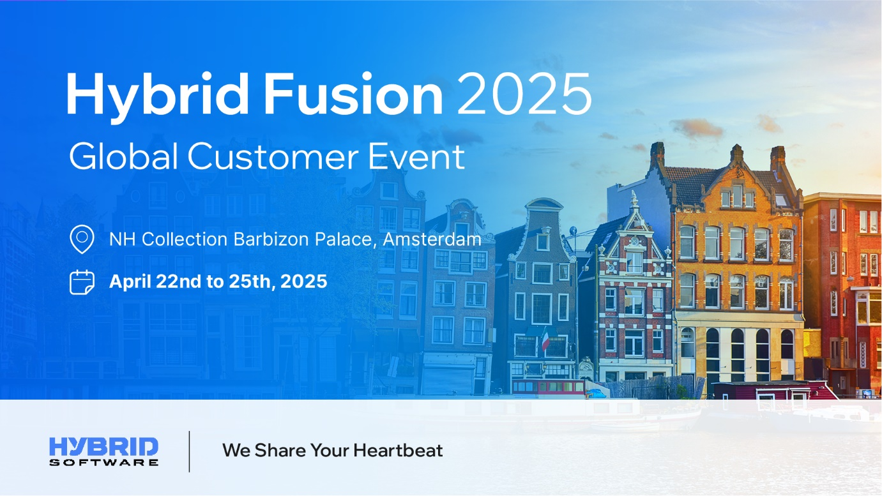
Image: Hybrid Fusion 2025.png

About Hybrid Software
With offices in Belgium, Germany, US, UK, Spain, France, Italy, and China, plus a global partner network, Hybrid Software is an enterprise software development company that focuses on innovative productivity tools for the graphic arts industry.

Hybrid Software’s CLOUDFLOW workflow, PACKZ and STEPZ editors, and print quality solutions offer a unique set of advantages, including native PDF workflows, enterprise cloud solutions, scalable technology with low cost of ownership, and direct integration with leading MIS solutions and output devices. These products are used by thousands of customers worldwide in all areas of prepress and print, including labels and packaging, folding cartons, corrugated, wide format, and digital printing. Hybrid Software is a subsidiary of Hybrid Software Group PLC (Euronext: HYSG).

Media Contact:

Hybrid Software
Steven Steenhaut, Director of Marketing
Email: stevens@hybridsoftware.com
Tel: +32 9 329 57 53

